**Quantum Computing application in bioinformatics**

Quantum computing with its ability to calculate and solve algorithms in parallel, at speeds far faster than conventional computers promises to revolutionize fields from chemistry and logistics to finance and physics. The thing is, while quantum computing is a technology for the world of tomorrow, it hasn’t yet advanced far enough for anyone to know what that world will actually look like.

**What is Quantum computing?**  
Quantum computing is the use of quantum-mechanical phenomena such as superposition and entanglement to perform computation.

**What is Qubits?**  
Qubits can take many forms, like atoms, ions, photons, and even the individual electrons that are running around on our electrical circuits. You can think of a qubit as the equivalent to the classic bits in modern computing, with a twist. Like bits, qubits are also measured using our binary system of 1s and 0s. But unlike a classical bit, qubits can be both a 1 and a 0 at the same time. It gets even stranger. Because a qubit can be both a 1 and a 0 at the same time, what you measure determines what a qubits final output will be. But how is this even possible? We have two qubit properties called superposition and entanglement.

***Superposition***  
In superposition, a qubit can be in multiple states at the same time, having a value of not just 0 or 1, but both, and any amount of numbers in between. This has some serious implications for computing. Imagine a quantum computer playing chess, it would be able to analyze every single possible move all at once, and then pick the best one. This is in comparison to a modern computer, which would need to analyze and take actions one at a time.

***Entanglement***  
Another strange property of qubits is their ability to be linked together, called entanglement, even over massive distances where there is zero possibility of a physical connection. When two qubits are linked together, they will both share a similar state, or value, being 1 or 0. And each qubit that you add to the mix doubles the possible processing capabilities.

If you entangled 300 qubits together, you could perform more parallel computations than there are known atoms in the universe.

<https://omicstutorials.com/wp-content/uploads/2019/08/qubits_bioinformatics.jpg>

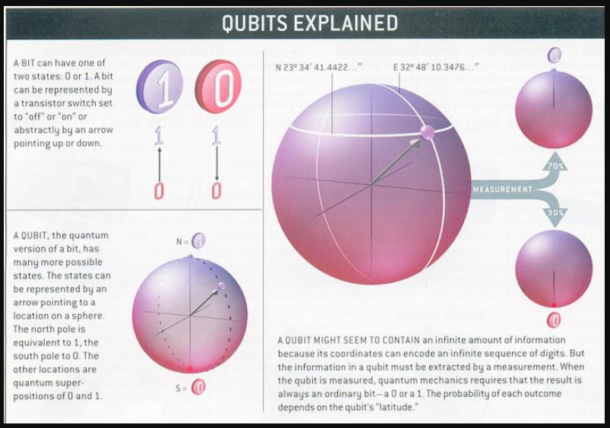

**How Quantum computing differ from classical computing?**  
All computing systems rely on a fundamental ability to store and manipulate information. Current computers manipulate individual bits, which store information as binary 0 and 1 states.

Quantum computers leverage quantum mechanical phenomena to manipulate information. To do this, they rely on quantum bits, or qubits. Qubits are fundamental to quantum computing and are somewhat analogous to bits in a classical computer.

Another fundamental difference between classical and quantum computing is in the basic set of operations. Classical computing is based on binary operations, such as the NOT and AND gates. These operations are universal: any other boolean operation can be replicated using NOTs and ANDs. They are also non-reversible: given the result of an AND gate, I cannot deduce the input variables. By contrast, quantum evolution is reversible, as dictated by the Schrdinger equation. Events which destroy reversibility, such as measurements, lead to a loss of quantum behavior. To have a quantum gain, it is important to only use reversible, unitary gates. It can be shown that a small set of these gates are also universal.

In general, a quantum algorithm is a sequence of five steps:  
1.Encode the input data into the state of a set of qubits.

2.Bring the qubits into superposition over many states (i.e., use quantum superposition).

3.Apply an algorithm (or oracle) simultaneously to all the states (i.e., use quantum entanglement amongst the qubits); at the end of this step, one of these states holds the correct answer.

4.Amplify the probability of measuring the correct state (i.e., use quantum interference).

5.Measure one or more qubits.

According to quantum mechanics, the result of the measurement is random. We want to engineer the algorithm so that the most probable answer is interpretable as a classical result which encodes the solution to our problem.

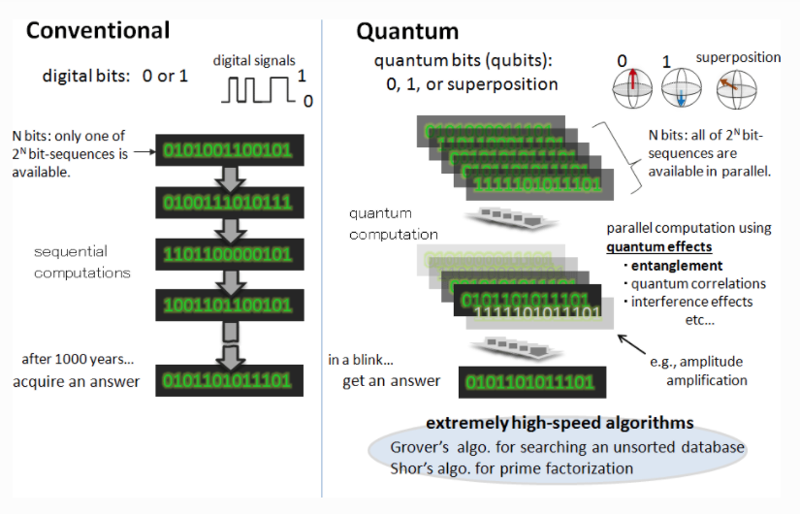

**Inside a quantum computer**  
There are a few different ways to create a qubit. One method uses superconductivity to create and maintain a quantum state. To work with these superconducting qubits for extended periods of time, they must be kept very cold. Any heat in the system can introduce error, which is why quantum computers operate at temperatures close to absolute zero, colder than the vacuum of space.

As such quantum computers are highly sensitive to interference from temperature, microwaves, photons, even the electricity running the machine itself. With the heat you’ve got lots of electrons moving around, bumping into each other, which can lead to the qubit’s decoherence. That’s why these rigs have to be cooled to near absolute zero on order to operate.

Outer space in the shade is between two and three degree Kelvin. Outer space is much too warm to do these types of calculations.Instead, the lowest levels of a quantum computer rig, where the calculations themselves take place, exist at a frosty 10 millikelvin a hundreth of a degree above absolute zero. we probably shouldn’t expect desktop quantum computers running at room temperature to exist within the next few decades perhaps even within our lifetimes.

Surprisingly, these systems are fairly energy efficient. Aside from the energy needed to sufficiently cool the system for operation (a process that takes around 36 hours) IBM’s 50-qubit rig only draws 10 to 15 kilowatts of power roughly equivalent to 10 standard microwave ovens

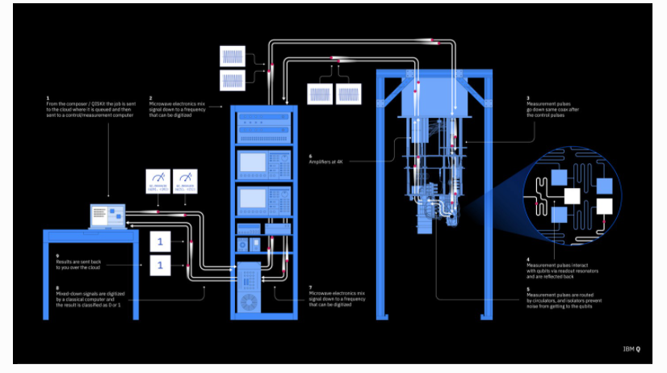

**Types of Quantum Computer**  
There are currently two main approaches to physically implementing a quantum computer: analog and digital.

Analog approaches are further divided into quantum simulation, quantum annealing, and adiabatic quantum computation.

Digital quantum computers use quantum logic gates to do computation. Both approaches use quantum bits or qubits.

